- Use the IF function in Excel to create a column that labels each order in a food delivery dataset as 'High Value' if the total amount is ₹500 or more, otherwise 'Regular'.
ANSWERS:
Restaurant_Name | Total_Amount | Order_Category
Empire Restaurant | 650 | High Value
Leon Grill | 320 | Regular
Meghana Foods | 890 | High Value
Corner House | 240 | Regular
Truffles | 520 | High Value
Chai Point | 180 | Regular
Behrouz Biryani | 750 | High Value
Domino's Pizza | 499 | Regular

- Given a list of cricket players and their total runs, use a nested IF formula in Excel to assign a player rating: 'Star' for 1000+ runs, 'Pro' for 700-999, 'Rising' for 400-699, and 'Newbie' for below 400.
Hint: Use multiple IF statements inside each other to handle all categories.
ANSWERS:
Player_Name | Total_Runs | player_rating
Virat Kohli | 1250 | Star
Shubman Gill | 850 | Pro
Yashasvi Jaiswal | 620 | Rishing
Rinku Singh | 380 | Newbie
Suryakumar Yadav | 910 | Pro
Tilak Varma | 450 | Rishing
Dhruv Jurel | 290 | Newbie
Rohit Sharma | 1100 | Star

- In an Excel sheet of Flipkart orders, add a column that shows 'Eligible' if the payment method is 'Prepaid' AND the order status is 'Delivered' using the AND function with IF.
ANSWERS:
Payment_Method | Order_Status | Discount_Eligible
Prepaid | Delivered | Eligible
COD | Delivered | Not-Eligible
Prepaid | Returned | Not-Eligible
Prepaid | Delivered | Eligible
COD | In Transit | Not-Eligible
Prepaid | Cancelled | Not-Eligible
Prepaid | Delivered | Eligible

- For a playlist dataset (song name, artist, isDownloaded, isFavorite), use the OR function with IF to mark songs as 'Quick Access' if they are either downloaded OR marked as favorite.
ANSWERS:
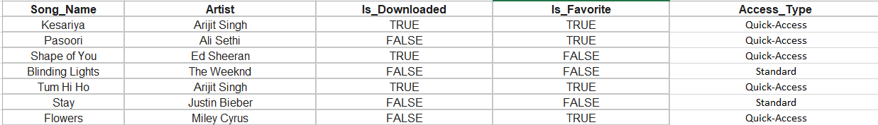

- Use the XOR function with IF in Excel to flag Zomato orders as 'Suspicious' only if exactly one of these is true: the delivery address is new OR the payment is by cash, but not both or neither.
Hint: XOR returns TRUE only when exactly one condition is true.
ANSWERS:
Is_New_Address | Is_Cash_Payment | Order_Flag
TRUE | FALSE | Suspicious
FALSE | TRUE | Suspicious
TRUE | TRUE | Normal
FALSE | FALSE | Normal
TRUE | FALSE | Suspicious
FALSE | TRUE | Suspicious
TRUE | TRUE | Normal

